NAME………………………………………………………….INDEX NO………………………………
STREAM………………………………………………CANDIDATE’S SIGNATURE………………
DATE………………………………………………….SCHOOL………………………………………
ART AND DESIGN
442/1
PAPER 1
MARCH-2025
TIME 1Hr 30Min

CEKENAS END OF TERM ONE EXAM-2025
FORM FOUR EXAM
Kenya Certificate of Secondary Education. (K.C.S.E)

INSTRUCTIONS TO CANDIDATES.
a) Write your name and admission number, class and date in the spaces provided above.
b) Sign and write the date of examination provided.
c) This paper has three sections A, B and C.
d) Answer all questions in section A and B
e) Answer any question from section C.
f) Answer to all the question must be written in the spaces provided.
g) Where drawing and diagrams are appropriate, they should be included within the text of your answers.
For Examiners’ Use Only.
Section | Question | Maximum score | Score
A | 1 | 20
B | 2 | 05
B | 3 | 05
B | 4 | 05
B | 5 | 05
B | 6 | 05
C | 7,8,9 | 15
TOTAL |  | 60

SECTION A (20MARKS)
Answer all the questions in this section in the spaces provided.
1.(a) What is line as used in Art and Design. (1mark)
……………………………………………………………………………………………………….
………………………………………………………………………………………………………. ……………………………………………………………………………………………………….
(b) Name the tool below and state its function. (2marks)

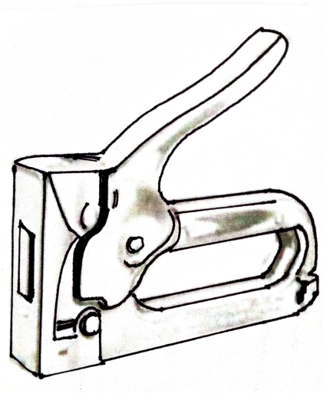
……………………………………………………………………………………………………….
……………………………………………………………………………………………………….
……………………………………………………………………………………………………….
……………………………………………………………………………………………………….
(c) Contrast between symmetrical and asymmetrical balance. (2marks)
……………………………………………………………………………………………………….
………………………………………………………………………………………………………. ……………………………………………………………………………………………………….
……………………………………………………………………………………………………….
………………………………………………………………………………………………………. ……………………………………………………………………………………………………….
(d) Study the following images and identify the type of rhythm in each picture. (3marks)

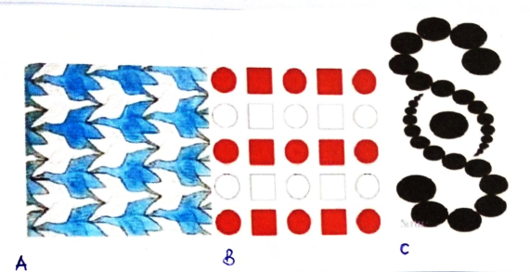
A……………………………………………………………………………………………………
B……………………………………………………………………………………………………
C……………………………………………………………………………………………………
(e) State 2 roles of packaging design. (2marks)
……………………………………………………………………………………………………….
………………………………………………………………………………………………………. ……………………………………………………………………………………………………….
(f) State two functions of a mask in traditional African society. (2marks)
……………………………………………………………………………………………………….
………………………………………………………………………………………………………. ……………………………………………………………………………………………………….
(g) State the main function of a stopper on an earing. (1mark)
……………………………………………………………………………………………………….
………………………………………………………………………………………………………. ……………………………………………………………………………………………………….
(h) Explain a warp –faced plain weave. (2marks)
……………………………………………………………………………………………………….
………………………………………………………………………………………………………. ……………………………………………………………………………………………………….
(i) Explain the term “priming” and state its function in painting. (2marks)
……………………………………………………………………………………………………….
………………………………………………………………………………………………………. ……………………………………………………………………………………………………….
……………………………………………………………………………………………………….
………………………………………………………………………………………………………. ……………………………………………………………………………………………………….
(j) Design a motif to be used in block printing and show its appearance on a block in readiness for printing. (3marks)

SECTION B (20marks)
Answer all the questions in this section in the spaces provided.
2.(a) Define dominance. (1mark)
……………………………………………………………………………………………………….
………………………………………………………………………………………………………. ……………………………………………………………………………………………………….
(b) State four ways of creating dominance. (4marks)
……………………………………………………………………………………………………….
………………………………………………………………………………………………………. ……………………………………………………………………………………………………….
……………………………………………………………………………………………………….
………………………………………………………………………………………………………. ……………………………………………………………………………………………………….
……………………………………………………………………………………………………….
………………………………………………………………………………………………………. ……………………………………………………………………………………………………….
3. Below is a tool used in Art Processes.

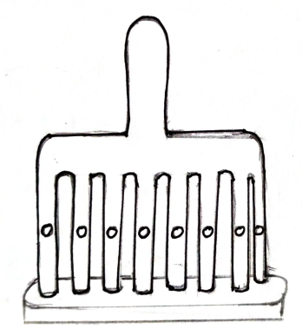
(a) Name the technique in which the above tool is used. (1mark)
……………………………………………………………………………………………………….
………………………………………………………………………………………………………. ……………………………………………………………………………………………………….
(b) Name the tool. (1mark)
……………………………………………………………………………………………………….
………………………………………………………………………………………………………. ……………………………………………………………………………………………………….
(c) Give 3 functions of the above tool. (3marks)
……………………………………………………………………………………………………….
………………………………………………………………………………………………………. ……………………………………………………………………………………………………….
……………………………………………………………………………………………………….
………………………………………………………………………………………………………. ……………………………………………………………………………………………………….

4.(a) What is a kiln? (1mark)
……………………………………………………………………………………………………….
………………………………………………………………………………………………………. ……………………………………………………………………………………………………….
(b) Identify and state the function of the following tool used in firing. (2marks)
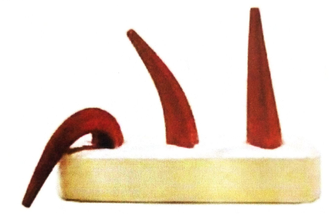
………………………………………………………………………………………………………. ………………………………………………………………………………………………………. ………………………………………………………………………………………………………. ………………………………………………………………………………………………………. ……………………………………………………………………………………………………….
(c) State any two states of clay. (2marks)
……………………………………………………………………………………………………….
………………………………………………………………………………………………………. ……………………………………………………………………………………………………….
……………………………………………………………………………………………………….
5. The illustrations below represent four equal tiles decorated with a single motif. Sketch the composite panel of the four tiles in the spaces provided below. (5marks)
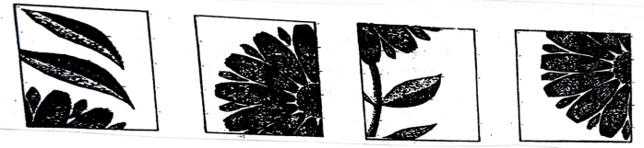
(i) (ii) (iii) (iv)

6. In the spaces below create a drawing to show “mother hen”. (5marks)

SECTION C (15marks)
Answer any one question in this section.
7.(a) Differentiate between ornaments from jewellery. (1mark)
……………………………………………………………………………………………………….
……………………………………………………………………………………………………….
(b) State and explain 5 factors to be considered when designing ornaments. (5marks)
……………………………………………………………………………………………………….
………………………………………………………………………………………………………. ……………………………………………………………………………………………………….
……………………………………………………………………………………………………….
………………………………………………………………………………………………………. ……………………………………………………………………………………………………….
……………………………………………………………………………………………………….
………………………………………………………………………………………………………. ……………………………………………………………………………………………………….
(c) Define the following terms used in ornament making. (2marks)
(i) Annealing
(ii) Soldering
……………………………………………………………………………………………………….
………………………………………………………………………………………………………. ……………………………………………………………………………………………………….
……………………………………………………………………………………………………….
………………………………………………………………………………………………………. ……………………………………………………………………………………………………….

(d) Outline five basic steps used in creating a pendant. (5marks)
……………………………………………………………………………………………………….
………………………………………………………………………………………………………. ……………………………………………………………………………………………………….
……………………………………………………………………………………………………….
……………………………………………………………………………………………………….
……………………………………………………………………………………………………….

(e) Explain two roles of ornaments in the African Traditional Society. (2marks)
……………………………………………………………………………………………………….
………………………………………………………………………………………………………. ………………………………………………………………………………………………………. ………………………………………………………………………………………………………. ………………………………………………………………………………………………………. ……………………………………………………………………………………………………….
8. The illustrations A and B below represents an Art and Design technique.
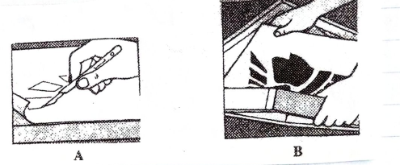
(a) Identify the technique. (1mark)
……………………………………………………………………………………………………….
……………………………………………………………………………………………………….

(b) Describe the process of producing a design using the technique. (10marks)
……………………………………………………………………………………………………….
………………………………………………………………………………………………………. ……………………………………………………………………………………………………….
……………………………………………………………………………………………………….
………………………………………………………………………………………………………. ……………………………………………………………………………………………………….
……………………………………………………………………………………………………….
……………………………………………………………………………………………………….
……………………………………………………………………………………………………….
……………………………………………………………………………………………………….
……………………………………………………………………………………………………….
……………………………………………………………………………………………………….
……………………………………………………………………………………………………….
………………………………………………………………………………………………………. ……………………………………………………………………………………………………….
……………………………………………………………………………………………………….
(c) Outline four steps to be followed when mounting the work using matt method. (4marks)
……………………………………………………………………………………………………….
……………………………………………………………………………………………………….
……………………………………………………………………………………………………….
……………………………………………………………………………………………………….
……………………………………………………………………………………………………….
………………………………………………………………………………………………………. ……………………………………………………………………………………………………….
9.(a) What is a badge. (1mark)
……………………………………………………………………………………………………….
……………………………………………………………………………………………………….
(b) Illustrate a badge in the spaces provided below and show the components of a badge. (11marks)
……………………………………………………………………………………………………….
………………………………………………………………………………………………………. ……………………………………………………………………………………………………….
……………………………………………………………………………………………………….
………………………………………………………………………………………………………. ……………………………………………………………………………………………………….
……………………………………………………………………………………………………….
……………………………………………………………………………………………………….
……………………………………………………………………………………………………….
……………………………………………………………………………………………………….
……………………………………………………………………………………………………….
……………………………………………………………………………………………………….
……………………………………………………………………………………………………….
……………………………………………………………………………………………………….
……………………………………………………………………………………………………….
……………………………………………………………………………………………………….
……………………………………………………………………………………………………….
……………………………………………………………………………………………………….
……………………………………………………………………………………………………….
……………………………………………………………………………………………………….
……………………………………………………………………………………………………….
……………………………………………………………………………………………………….
……………………………………………………………………………………………………….
……………………………………………………………………………………………………….
……………………………………………………………………………………………………….
……………………………………………………………………………………………………….
……………………………………………………………………………………………………….
……………………………………………………………………………………………………….
……………………………………………………………………………………………………….
………………………………………………………………………………………………………. ……………………………………………………………………………………………………….
(c) State the function of colour in a badge. (3marks)
……………………………………………………………………………………………………….
………………………………………………………………………………………………………. ………………………………………………………………………………………………………. ……………………………………………………………………………………………………….

